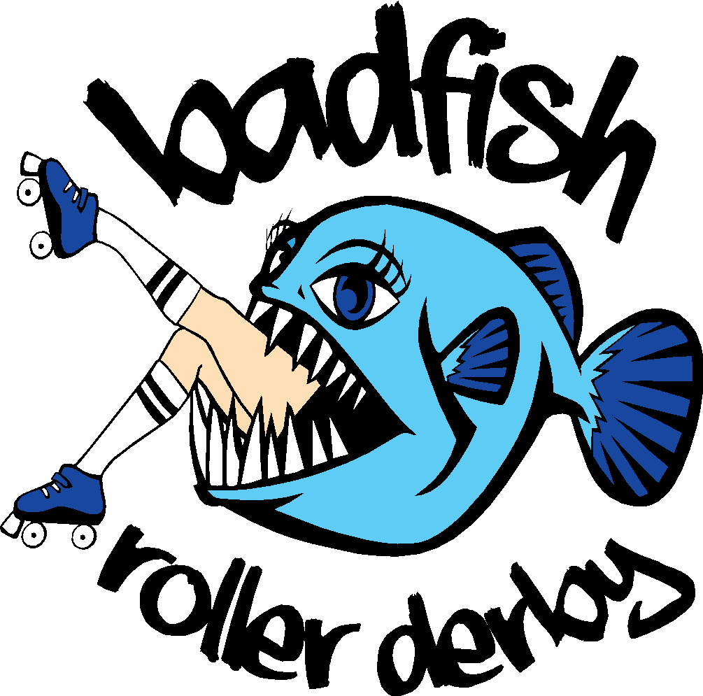
Welcome to Badfish Roller Derby!

We are excited that you are interested in joining our league, and have put together some information to get you started. Badfish Roller Derby, founded in January 2014, is a non-profit 501c3, skater-operated, full-contact, locally competitive, flat track roller derby league. We strive to maintain home teams as well as a competitive travel team. We nurture a family-friendly atmosphere and give back to our local communities through donation and volunteer opportunities. We fundraise to support our league travel team expenses, facility rental, specialty league events and prizes, and pertinent league equipment.
Board Members
Buster Chassis Slammin’ de Beers
Sherry Bomb Nursie Knockout
Squirrel Deja Vu

Coaches
Creepy Taco Beers Nacho Nursie
Vicious Squirrel Deja
Danger Snark Nnegration

Facebook group: Badfish Roller Derby Practice and Basic League info (pre-membership group)
BFRD Guppies (new members only)
BFRD Chatter (members only)
BFRD League Info (members only)
Bad Fit club (members only)

Contact information: BadfishRollerDerby@gmail.com

Practice schedule: Tuesday 7:00 - 9:00 PM
(Subject to change) El Dorado Park
2760 E Barrios St., Long Beach 90815

Thursday 7:00 - 9:00 PM
Cherry Park
1901 E 45th St., Long Beach 90807

Sunday 9:00 - 11:00 AM
Bayshore Rink
14 54th Pl,. Long Beach 90803
Our league is broken up into three levels of skaters.

Guppies - Guppies, or you may hear this group referred to as Fresh Meat, are newer skaters to derby. You learn the basics in this group. This group focuses on learning to skate, start, stop, derby stance, and introduction to being touched by others with wheels underneath you. You learn the necessary skills to pass the WFTDA minimum skills and written tests. These skaters are NOT cleared for contact (hitting) during practice.

Sea Monkeys - Skaters who are on the verge of becoming a part of The School, so we want them to learn from the school. You are not cleared for contact, but are invited to play with The School and do positional blocking. (Do not engage in any type of contact outside of the league until pass your skills assessment.)

The School - All skaters cleared for contact. You may engage in roller derby activities, including full contact scrimmaging and games, make rosters, go to scrimmages and soak up all the derby knowledge out there!

TEAMS - Badfish has four teams, Badfish Allstars, Badfish Sea Team, The Killer Krakens and The Saltwater Sea Hags. The Allstars and Sea Team are our travel teams, and the Krakens and the Sea Hags are our home teams. Once you pass the minimum skills assessment tests you are eligible to roster or try out for a team. (Currently we are playing a mixed level travel team and rebuilding home teams.)

League Requirements and Information

- Dues are $40 per month, payable to Badfish Roller Derby. Cash, check or PayPal to badfishtreasurer@gmail.com. Due on the 1st of the month. Please choose the friends and family option.

- Skaters are required to join and actively participate in league events. Roller Derby is known for its DIY nature. It takes every one of us working hard to make games happen. Each skater will have duties on game day. If you are not assigned a specific duty, please volunteer!

- Signed Waiver , code of conduct, contact form, copies of personal medical insurance card and a photo ID must be turned in.

- Attendance is mandatory, You must come once a week to remain in good standing with the league. And you must have at least 66% attendance overall to be the initial players considered for games.

- Members must have good sportsmanship at all times, whether on skates or off.

- You must obtain WFTDA insurance within 30 days of joining or before your first game, whichever comes first.

- Learn the rules of the game. Go to the WFTDA website (wftda.com/rules) and read/print the current rules. There are a lot of rules and many can be confusing so ask tons of questions.

Tips on Preparation Training

- If you are new to skating or just getting back into after a long break, try to be in your skates as often as you can. The more you do in your skates, the quicker you will progress at practice. You need to feel comfortable with wheels under you before you can really work on being successful at the skills required to play derby.

- Strength, endurance and core training are essential to becoming a great derby player .

- Practice outside of scheduled derby practice hours to become the best derby player possible. You will progress MUCH faster the more you are on your skates. If you need suggestions, just ask a coach.

- Gear up! In order to play derby you need the required equipment. That includes Derby Roller Skates, Helmet, Mouth Guard, Elbow Pads, Knee Pads, and Wrist Guards. That’s the bare minimum to practice and play roller derby.

Don’t Get Discouraged! - Remember, we all started somewhere. Some of us had never skated until we started playing roller derby. Keep coming to practice and give your BEST effort. Effort requires zero ability and can be given by anyone. You WILL improve if you show up!

Roller derby is not for everyone, but the roller derby community and our derby family can be. So even if you prefer no-contact skating or no skating at all, we have a spot for you within the league. Please ask any of the Board Members for more information.

Wicked Skatewear is a good place to start looking for Derby gear. Tell them you are with Badfish for our league discount.

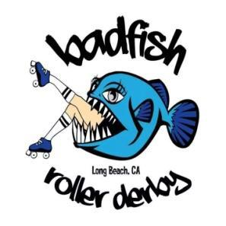
Badfish Roller Derby
Assumption of Risk and Release from Liability Agreement

This agreement is entered into between Badfish Roller Derby (BFRD) and the undersigned participant with respect to participation in BFRD league activities. In consideration of the participation in BFRD activities, participant agrees to the following:

1. Participant forever waives any cause of action against BFRD and its affiliates, its Owners, and agents, which might arise from participation in this activity. Initial_____________ .

2. In the event a third party (or parties) is injured in any occurrence in which the undersigned participates, the undersigned shall forever indemnify, defend, and hold nameless BFRD, its affiliates, its owners, and agents from ALL costs and expenses which arise from claims by such injured parties. Initial_____________ .

3. Participant authorizes any medical treatment deemed necessary in the event of any injury while participating in BFRD activities. It is the responsibility of participant to carry full and complete insurance coverage for personal bodily injury and personal property damage to participant and any other individuals who may be injured resulting from league activities (or, in its absence, agree to pay all costs of rescue and/or medical services that may be incurred on behalf of the participant). Initial_____________ .

4. Participant understands and accepts that roller skating, in its various forms, is a hazardous sport and has many dangers and risks, which include serious bodily injury and death. Participant hereby agrees to freely and expressly assume and accept any and all risks of injury. Initial_____________ .

5. Participant represents that she is physically fit and able to safely participate in this physically demanding activity, and that she does not suffer from any injury, defect, ailment, illness, or the like which could conceivably lead to injury or death from participation in this activity. Initial_____________ .

6. The participants Assumption of Risk and Release from Liability Agreement is on behalf of the league participant, and her spouse, personal representatives, assigns, heirs, next of kin, family, relatives, executors, trustees, conservators, administrators, agents, and guardians. Initial_____________ .

7. Participant agrees to give up their right to a trial by court or jury. Any dispute or claim between participant and BFRD, including those arising out of or related to this Agreement, the interpretation of this Agreement, or any damages, shall be settled by binding arbitration in accordance with the Rules of the American Arbitration Association. The arbitrator’s award shall be final and binding upon the parties, and judgment upon the award may be entered by any court of competent jurisdiction. The place of arbitration shall be the county of Los Angeles. Initial_____________ .

8. Participant agrees to provide their own required protective gear that must be worn at all times during league activities. Initial_____________ .

9. I understand, consent to, and authorize, in advance, the use of my name, voice, picture or other likeness, in combination or alone, in any broadcast, telecast, print medium, advertising, promotion, or other account of a league event as approved by BFRD. Initial_____________ .

WAIVER OF LIABILITY

Participant, member, guest, or patron shall participate in roller skating and/or use any of BFRD activities at his/her own risk. BFRD shall not be liable for any damages for personal injuries sustained by any participant, member, guest, or patron in, on, or about the premises on which BFRD gathers for practice, games, scrimmages or any other league related activities.

PERSONAL PROPERTY AND VALUABLES

BFRD shall not be liable for the loss or theft of, or damage to, the personal property of any participant, member, guest, or patron.

By signing this form, I acknowledge that I have read the document in its entirely and fully understand this release. I am 18+ years of age and agree to the terms above. I am signing of my own free will and volition.

________________________________________________________________________________________________________________________
Signature Date

________________________________________________________________________________________________________________________
Print Name Email Address
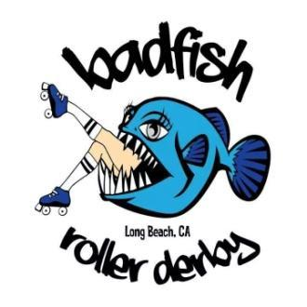
Badfish Roller Derby Skater information and Emergency Contact

Contact Information
Legal Name
Derby Name Skaters #
Street Address
City State Zip
Email Address
Mobile phone Date of Birth
Insurance Information
Health Insurance Provider
Policy Number Exp. Date
Preferred Hospital
Known Allergies
WFTDA #
Emergency Contact
Primary
Name
Phone Number
Address
City State Zip
Relationship to skater
Secondary
Name
Phone Number
Address
City State Zip
Relationship to skater

The following is a copy of the Badfish Roller Derby Code of Conduct and Participation Agreement that will need to be signed and submitted with all new member forms. Please read it carefully and speak to a board member for any questions or comments. The participants, coaches, and officials shall be required to follow the Code of Conduct, set forth as follows:

CODE OF CONDUCT
I hereby pledge to be responsible for my words and actions while attending, coaching or
participating in a Badfish Roller Derby event and shall conform my behavior to the following code of conduct:
- I will wear protective gear at all times that I have on skates.
- I will not use or encourage anyone else to use drugs or alcohol while participating in a sport event.
- I will not engage or encourage anyone else to engage in unsportsmanlike conduct with any coach, player, participant, official or any other attendee.
- I will not engage or encourage anyone else to engage in any behavior which would endanger the health, safety or well-being of any coach, player, participant, official or attendee.
- I will treat any coach, player, participant, official or any other attendee with respect.
- I will not engage in or encourage verbal or physical threats or actions aimed at any coach, player, participant, official or any other attendee.
- I will pay dues in full and on time.
- I will fulfill attendance requirements to the best of my ability and have the courtesy to notify the proper person if I will be late or absent from a scheduled event or practice.
- I will strive to learn new skills and improve myself as an athlete and a teammate.
- I will work to create a welcoming environment for every Badfish Member, helping my league-mates to realize their potential in athletics and beyond.
- I will abide by any decision rendered by the board regarding my behavior.
- I will conduct myself in the best interest of Badfish Roller Derby when in uniform or at Badfish events such as recruiting, bouts, after parties, roll-outs, fundraisers, etc.
- I will read the Badfish operating manual and abide by its contents.

___________________________________________
Participant’s Signature and Date

____________________________________________
Printed Name of Participant

New League Member check-list
Done | Task | How long you have to complete | Date
 | Contacted Badfish / Came to recruit night | Done. Good Job! :)
 | Signed / Turned in waiver | Before your first practice
 | Signed / Turned in emergency contact form | Before your first practice
 | Signed / Turned in Code of Conduct form | Before your first practice
 | Turned in copies of Identification and Personal Insurance Info | Before your first practice
 | Have all your own derby gear including Helmet, Mouth guard, Elbow Pads, Knee Pads, Wrist Guards and Derby Skates | Before your first practice
 | Joined FB group: Badfish League info | Immediately following your first practice (Message who recruited for help)
 | Joined FB group: BFRD Chatter forum | Immediately following your first practice (Message who recruited for help)
 | Joined FB group: BFRD Guppies | Immediately following your first practice (Message who recruited for help)
 | Joined Team Snap | Immediately following your first practice (Message who recruited for help)
 | Paid Dues | 14 days from join date
 | Purchased WFTDA insurance | 30 days from join date

